Pantalla escritorio: **1920 x 560 px**

Ejemplo:

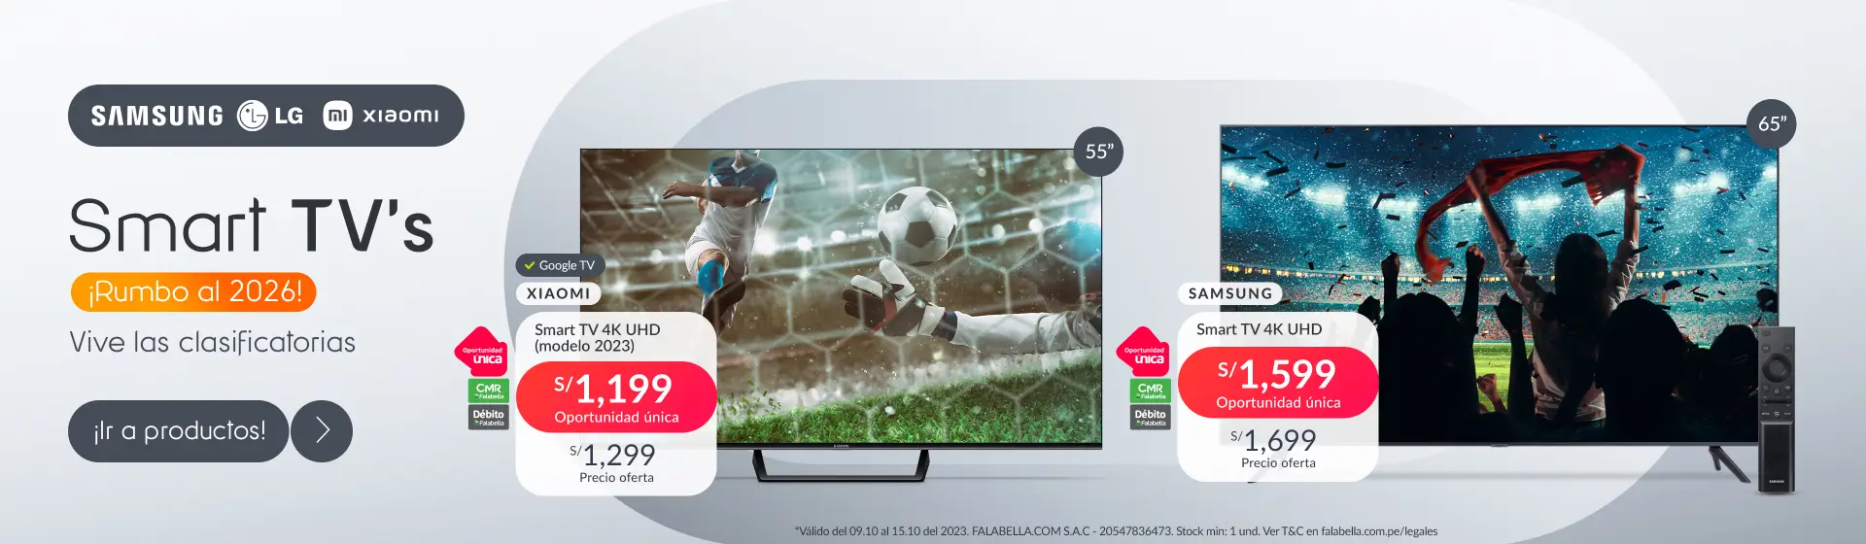

<https://images.falabella.com/v3/assets/bltf4ed0b9a176c126e/bltd8164f2b240ee97f/65203ff99f3cb1896a551050/01-Vitrina-DK-TVS-091023-mdcb.jpg?disable=upscale&format=webp&quality=70&width=1920>







Pantalla móvil: **700 x 370 px**

Ejemplo: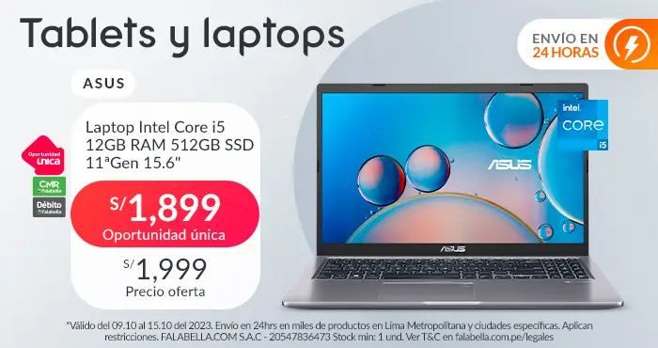

<https://images.falabella.com/v3/assets/bltf4ed0b9a176c126e/blt52e243e0a1782e5a/652038449f3cb154e3550ff4/05-Vitrina-MB-computacion-091023-mdcb.jpg?disable=upscale&auto=webp&quality=70&width=1920>

